Reverse Ajax and Prototype with Mongrel handlers
http://www.danielcadenas.com/search/label/reverse%20ajax
Daniel Cadenas
MONDAY, AUGUST 25, 2008
The most common use of reverse Ajax or Comet calls is having some piece of information in your webpage that you want to update as soon as some remote event triggers, always without polling. Let's make a little experiment to see how this works:

Client side
So you start a request, the web server waits for the event to happen, and finally, a while later, the response is sent back to the client. When this process ends, it's very common that you want to start it again. You want to have a continuous Ajax call when the event is also continuous, when it can happen many times.
To deal with this, as I'm using Prototype, I made this JavaScript routine to start listening for the event:
function continuousAjaxCall(url, method, params,
successCallback){
waitingForResponse = false;
function iteration(){
if(!waitingForResponse){
waitingForResponse = true;
new Ajax.Request(url,
{
method: method,
parameters: params,
onSuccess: theSuccessCallback
});
}
};

function theSuccessCallback(transport){
successCallback(transport.responseText);
waitingForResponse = false;
};

return new PeriodicalExecuter(iteration, 1);
}
So now if you do:
continuousAjaxCall("/WebFacade/SomeWebService", "post",
"taskid=" + taskNumber, callback);
You will start listening to the web service in /WebFacade/SomeWebService using method post and with taskid=taskNumber as the http body parameter.
The callback is a routine that will be executed each time the event is triggered. For example we could do this to show the result from the web service:
function callback(responseText){
alert(responseText);
}
The routine returns a prototype PeriodicalExecuter that you can use to stop listening:
pe = continuousAjaxCall(...
pe.stop()

Server side
In the server side I have some Mongrel handlers serving the client pages. The key here is the line sleep 1 until @@submitted_value that waits until some new value is submitted and only then responds to the ajax request:
require 'rubygems'
require 'mongrel'
include Mongrel

@@submitted_value = nil

class ReverseAjaxHandler < HttpHandler
def process(request, response)
response.start(200) do |head, out|
head['content-type'] = 'text/html'
sleep 1 until @@submitted_value
out << @@submitted_value
@@submitted_value = nil
end
end
end

class SendHandler < HttpHandler
def process(request, response)
response.start(200) do |head,out|
#Code that renders the "/send" page and sets the @@submitted_value
#...
#...
end
end
end

h = HttpServer.new("0.0.0.0", "5000")
h.register("/wait", ReverseAjaxHandler.new)
h.register("/send", SendHandler.new)
h.register("/files", DirHandler.new('.'))
h.run.join
It's nice to have this as a Mongrel handler because it's simple, but keep in mind that this implementation was made just for the purpose of this example and it is not thread safe. I don't control the access to the global variable @@submitted_value.

Demo
I made a little demo about this using some mongrel handlers like the one in the previous post:
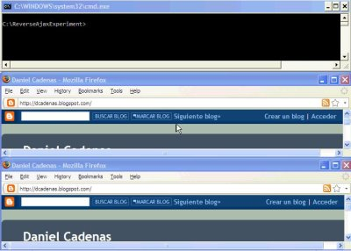
The code for this article and its demo can be found here.

